Embargoed until Tues., September 22, 2020 at 8 a.m. ET

BioCanRx Invests $10M in Promising New Cancer Immunotherapy
Research and Biomanufacturing to Benefit Canadians

Funding will move novel cancer technologies from the lab to the clinic

OTTAWA, ON (Tuesday, September 22, 2020, 8 a.m. ET) - BioCanRx, Canada’s Immunotherapy Network, today announced funding of $10M for 14 cancer immunotherapy research projects and eight core and biomanufacturing facilities. In addition to BioCanRx’s investment, matching partner contributions of $16.5M increase the total investment in Canadian translational cancer immunotherapy research and manufacturing facilities to $26.5M.

Cancer is one of the biggest health challenges facing Canadians. Nearly 1 in 2 Canadians is expected to develop cancer in their lifetime. BioCanRx is working to turn the tide and improve outcomes for patients by accelerating the development of promising immunotherapy treatments which could be more effective, affordable and safe than conventional cancer therapies.

“We’re collaborating and building teams across Canada to find new ways for the body’s immune system to outsmart and kill cancer. This new funding is helping to bridge the research gap between lab discoveries and clinical trials to ultimately benefit patients,” said Dr. John Bell, BioCanRx’s Scientific Director and a senior cancer research scientist at The Ottawa Hospital and the University of Ottawa.

BioCanRx’s investments in the development of novel therapies continue to be guided and benchmarked by its Research Management Committee composed of internationally renowned academics and industry leaders in the field of cancer immunotherapy. The focus of the newly funded projects includes highly innovative and novel approaches to cancer treatment, targeting difficult to treat cancers where current options are limited. The project investment portfolio includes cross-disciplinary teams from across the country working on new, rational combination approaches and unique cell, vaccine/virus-based and antibody immunotherapies. Investments in Canada’s biomanufacturing capacity also feature prominently and additional sites across the country will be added to our point-of-care cell manufacturing network to enhance access to life-saving therapies to patients across the country.

Full list of BioCanRx research projects.
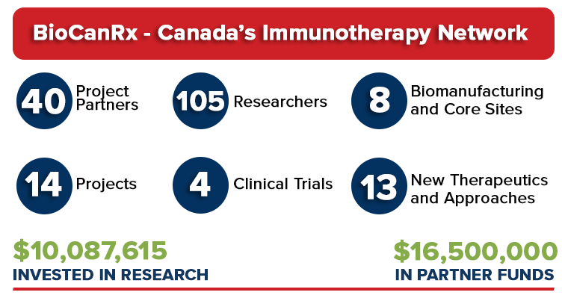
BioCanRx, a Government of Canada Network of Centres of Excellence, has been renewed for a 3-year cycle. In its first cycle of five years, BioCanRx invested $18.5M in Canadian immunotherapy research including eight “first-in-human” clinical trials. BioCanRx leveraged $62M in partnered funds and established core and biomanufacturing facilities to accelerate the pace of moving science discoveries out of the lab and into the clinic. A key investment enabled the building of Canadian capacity for point-of-care CAR T cell manufacturing. BioCanRx also formed the Cancer Stakeholder Alliance, made up of 51 cancer charities and non-government organizations, to help integrate the “patient voice” into all aspects of its clinical and science program and provide guidance with respect to health policy investments.

Additional Quotes:

Ken Newport, Chair, Board of Directors, BioCanRx:
“BioCanRx is investing in the best Canadian innovations in the field, always looking for a clear path to the clinic for the benefit of patients. It’s also key to invest in the next generation of researchers. That’s why we’re committed to training and helping to build capacity in Canada for a thriving health biotechnology sector.”

Dr. Stéphanie Michaud, President & CEO, BioCanRx:
“Working with our partners in industry, patient groups, not for profits and government organizations, BioCanRx is translating immune-based technologies from the lab into early phase clinical trials. We’re also committed to working in parallel to address the socio-economic factors necessary for their adoption in the Canadian healthcare system.”

Dr. Duncan Stewart, Executive Vice-President, Research, The Ottawa Hospital, CEO and Scientific Director, Ottawa Hospital Research Institute and Professor, University of Ottawa

“The Ottawa Hospital Research Institute is proud to host the BioCanRx network. Working together, we are providing crucial support for groundbreaking cancer immunotherapy research that could save and transform lives.”

Additional material including video and photos

About BioCanRx
BioCanRx, Canada’s Immunotherapy Network, is a network of scientists, clinicians, cancer stakeholders, academic institutions, NGOs and industry partners working together to accelerate the development of leading-edge immune oncology therapies for the benefit of patients. Our vision is to cure patients and enhance the quality of life of those living with cancer. BioCanRx invests in leading edge immune oncology research translating world-class technologies from the lab into early phase clinical trials. BioCanRx provides researchers with access to funding, expertise, training and manufacturing facilities and is a leader in the translation, manufacture and adoption of cancer immunotherapies. The network is committed to training and developing the talent needed for a thriving health biotechnology sector in Canada. BioCanRx receives funding from the federal government’s Networks of Centres of Excellence, and support from industry, the provinces and charities. The network is hosted by the Ottawa Hospital Research Institute.
https://biocanrx.com/

Media contacts for further details or interview requests:

Nancy Boyle, Director, Communications, Marketing & Engagement, BioCanRx
613-402-5680 / nboyle@biocanrx.com

April Henry, Specialist, Operations and Communications, BioCanRx
ahenry@biocanrx.com

Connect with BioCanRx:
Twitter
Facebook
Instagram
LinkedIn
YouTube

